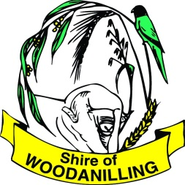
Fire Break Notice
&
Bush Fire Information
2019/2020

Action is required by landowners and occupiers
of ALL land in the Shire of Woodanilling

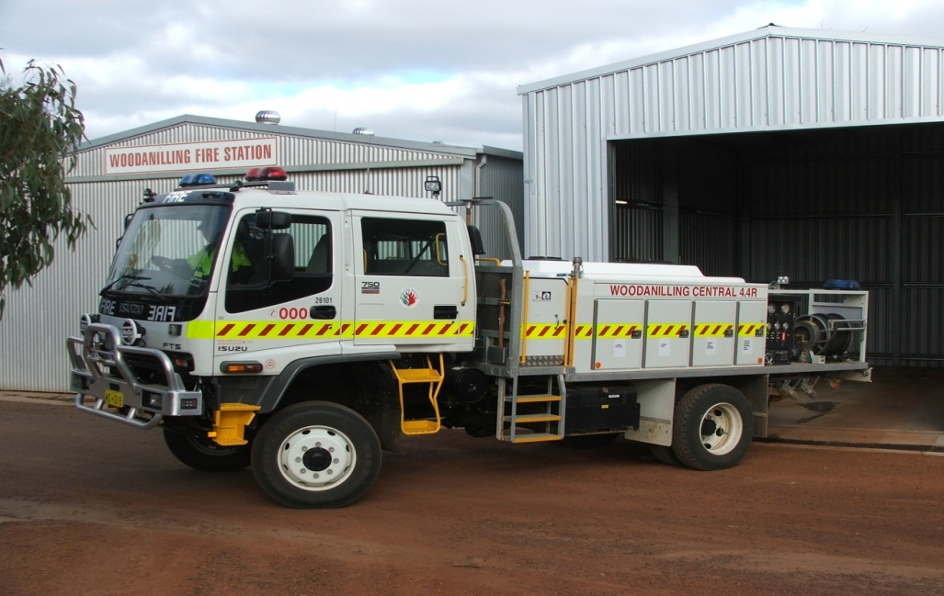

PLEASE READ COMPLETELY AND CAREFULLY

FIRST & FINAL NOTICE ◆ PENALTIES MAY APPLY

If In Doubt, Contact the Shire of Woodanilling
Or your Local Brigade

FOR EMERGENCIES DIAL 000
Harvest Ban Hotline – 9823 1056
for all fire ban information
CONTACT SHIRE TO BE NOTIFIED OF HVMB BY SMS OR WHATSAPP, AS THIS PHONE SERVICE IS BEING PHASED OUT.

ANY FIRE LIT DURING THE RESTRICTED AND PROHIBITED BURNING PERIOD 19TH SEPTEMBER TO 15TH APRIL (INCLUSIVE) WILL REQUIRE A PERMIT FROM YOUR LOCAL FCO AND/OR THE CHIEF BUSH FIRE CONTROL OFFICER.
Bush Fire Act 1954 (Section 33)

Pursuant to the power contained in Section 33 of the Bush Fire Act, 1954 you are hereby required to observe all requirements of this Fire Break Notice. Please read carefully, these are your legal requirements.

During the period from 15 NOVEMBER TO 15 APRIL inclusive you are required to have:-

- REGIONAL RURAL ZONE – OCCUPIED PROPERTIES

    - Immediately surrounding all homesteads, buildings, haystacks within 200 metres of a building, fuel storage tanks and drums, a ‘Low Fuel Zone’ of at least 10 metres wide.

    - A mobile fire fighting unit on standby and available for fire fighting purposes during the period from 15 November to 15 April.

    - A mobile fire fighting unit shall be in attendance or close proximity to harvesting operations, straw cutting or straw baling operations. The mobile fire fighting unit must be equipped and readily available for fire fighting purposes and trailers must be connected to a vehicle.

1.0.4 A fire access way shall be provided to all homesteads and shall be maintained free of all flammable material to a minimum of 4 metres trafficable surface and 4 metres vertical clearance.

1.1 REGIONAL RURAL ZONE – ABSENTEE LANDHOLDERS

1.1.1 Immediately surrounding all buildings, haystacks within 200 metres of a building, fuel storage tanks and drums, a ‘Low Fuel Zone’ of at least 20 metres wide.

1.1.2 A mobile fire fighting unit shall be in attendance or close proximity to harvesting operations, straw cutting or straw baling operations. The mobile fire fighting unit must be equipped and readily available for fire fighting purposes and trailers must be connected to a vehicle.

1.1.3 A fire access way shall be provided to all homesteads and shall be maintained free of all flammable material to a minimum of 4 metres trafficable surface and 4 metres vertical clearance.

2.0 LOCAL RURAL ZONE

2.0.1 A ‘Building Protection Zone’ is required around all buildings to a minimum width of 20 metres.
2.0.2 All Land in the Local Rural Zone is to be maintained in a ‘Hazard Reduced State’.
2.0.3 A mobile fire fighting unit shall be in attendance or close proximity to harvesting operations, straw cutting or straw baling operations. The mobile fire fighting unit must be equipped and readily available for fire fighting purposes and trailers must be connected to a vehicle.
2.0.4 A fire access way shall be provided to all homesteads and shall be maintained free of all flammable material to a minimum of 4 metres trafficable surface and 4 metres vertical clearance.

  - LOCAL RURAL ZONE – URBAN FARMLAND

2.1.1 When the land is classified as Urban Farm Land by the Shire, the provisions of the Regional Rural Zone –Occupied Properties and Regional Rural Zone –Absentee Landholders will apply.

3.0 RESIDENTIAL, COMMERCIAL, INDUSTRIAL ZONES

3.1 All land within these zones are to be maintained in a “Hazard Reduced State”.

3.2 If a dwelling is located on a lot, then in addition to 3.1 above, within a 10 metre radius of the dwelling you must:
3.2.1 Maintain dead grass at or below 50mm;
3.2.2 Removal of all dead branches from live standing trees or shrubs up to a height of 1.5 metres above the ground;
3.2.3 Removal of all dead trees or shrubs;
3.2.4 Removal of all branches from trees or shrubs that overhang the dwelling; and
3.2.5 1 metre clearance is required around all fire wood stacks/heaps.
4.0 ALL OTHER ZONES / RESERVES

4.1 For all other Zones and Reserves in the Shire, the Council will determine individual fire control requirements by means of a Fire Management Plan. This includes all reserves under its control via a Vesting or Management Order which may or may not be leased to other authorities, UCL (unallocated crown land), and reserves under the control of other authorities/bodies.

5.0 PLANTATIONS

5.1 A firebreak being a minimum of 15 metres width shall be constructed along the boundaries of separate ownership, and all formed public roads, or on such alternative locations as may be agreed between the Local Government authority and the plantation owner.

5.2 Internal fire breaks between compartments of up to 30 hectares must be a minimum of 6 metres wide and for compartments over 30 hectares, a minimum of 10 metres wide.

5.3 All fire breaks shall have a 5 metre trafficable surface with a minimum vertical clearance of 4 metres to allow access by fire fighting appliances.
VARIATIONS

If it is considered impractical for any reason to comply with any provision of this Notice, you may make written application detailing your proposed alternative fire prevention measures to the Council or its duly authorised officer, by no later than 1 October each year.

This application must be signed by the FCO for the area in which the land is situated to signify agreement to the variation. If the Council or its duly authorised officer does not grant permission, you must comply with the requirements of this notice.

A request for a variation to the Fire Break Notice for areas of non-arable land is considered acceptable, however the landholder must demonstrate that they have taken every possible action to clear the said land. Requests for variations that have been approved prior to 1 January 2014 remain in force until the lot is either sold or a residence is built on the lot.

PENALTIES THAT CAN BE IMPOSED

Failure to comply with this Notice | Up to $5,000
Offences relating to lighting fires in open air | Up to $3,000
Setting fire to the bush during prohibited burning times | Up to $250,000 and 14 years imprisonment
Failure of occupier to extinguish bush fire | Up to $10,000
Refusal to state name and abode or stating false name or abode | Up to $1,000
Failure to produce permit to burn | Up to $1,000

It is not necessary for Council to notify you or give you any prior warning that legal action may proceed for failing to comply with the requirements of this notice.

GUIDELINES FOR VEHICLE AND MACHINERY MOVEMENT BANS
(INCLUDING BANS ON OPERATION OF INTERNAL COMBUSTION ENGINES)

The following definitions shall apply to the guidelines on the ban of vehicle and machinery movement and the operation of internal combustion engines under Regulation 38A and 38B of the Bush Fires Regulations, 1954.

To register for the Harvest and Vehicle Movement Ban SMS Service please contact the Shire

LANEWAY/ROADWAY (NON GAZETTED)

A laneway/roadway is defined as having a trafficable surface, free of all flammable material, a minimum of 4 metres wide. Overhanging vegetation is to be pruned so as not to come into contact with any part of a vehicle.

REGISTERED ON AND OFF LOADING AREA

Registered On and Off Loading Area is defined as an area free of flammable material, save live standing trees to a radius of 50 metres from the centre of the area.
Areas are to be registered on an annual basis and must be received no later than 1 October each year.

DEFINITIONS

For the purposes of this notice, the following definitions apply:
Absentee Landholder – Any landholder who resides outside the Shire of Woodanilling unless the owner resides in an adjacent brigade district or an employee resides on the property.
Plantation - Any area of trees planted for commercial purposes, other than a windbreak - within gazetted town sites exceeding 3 hectares and elsewhere exceeding 10 hectares.
Building Protection Zone – is a Low Fuel Zone immediately surrounding a building and is designed to minimise the likelihood of flame contact with buildings. All trees and branches which overhang a building are to be removed;
Boundary – Means the external perimeter boundary of land contained within the same ownership, irrespective of whether it contains one or more allotments.
Firebreak – Means ground from which all flammable material has been removed, which is trafficable and on which no flammable material is permitted to accumulate during the prohibited and restricted burning periods.
Flammable Material – Means trash, dead grass, rubbish, leaf litter, sticks, dead branches, or other hazardous material, but does not include live standing trees, shrubs and cultivated plants located in gardens.
Hazard Reduced State – The removal of all hazardous material from the land excluding living plants and trees. Dead grass to be maintained at or below a height of 150mm.
Hazardous Material – Means any bush, plant, tree, vegetable, substance, object, thing or materials that may or is likely to catch fire and burn.
Lot – “lot” means a defined portion of land —
(a) depicted on a plan or diagram available from, or deposited with, the Authority and for which a separate Crown Grant or certificate of title has been or can be issued; or
(b) depicted on a diagram or plan of survey of a subdivision approved by the Commission; or
(c) which is the whole of the land the subject of -
(i) a Crown Grant issued under the Land Act 1933; (ii) a certificate of title registered under the Transfer of Land Act 1893; (iii) a survey into a location or lot under section 27(2) of the Land Administration Act 1997 or a certificate of Crown land title the subject of such a survey; (iv) a part-lot shown on a diagram or plan of survey of a subdivision deposited with the Authority; or (v) a conveyance registered under the Registration of Deeds Act 1856 - but does not include a lot in relation to a strata scheme, a lot in relation to a survey-strata scheme, or a lot shown as common property on a survey-strata plan, as those terms are defined in the Strata Titles Act 1985.
Low Fuel Zone – Means the removal of dead trees, leaf litter and trash, the removal of dead branches to a height of 1.5 metres from live standing trees or shrubs, and the maintenance of dead grass at or below a height of 100mm. Contained within the Low Fuel Zone a minimum of 2.5 metres of the zone must be maintained as a Firebreak or as maintained gardens and/or lawns.
Mobile Fire Fighting Unit — A mobile fire fighting unit is defined as having a minimum water carrying capacity of four hundred (400) litres, fitted with a fire fighting hose and pump capable of delivering water.
Non-arable Land — Land that is not capable of producing crops; unsuitable for farming; unsuited to the plough or tillage. Includes rocky outcrops, densely treed areas or creek lines etc.
Harvest and Vehicle Movement Ban — A ban on the movement of all vehicles and machinery and the operation of internal combustion engines within the Shire or part of the Shire during a time as specified in a notice or broadcast (Regulation 38A & 38B of the Bush Fire Regulations, 1954) with the exception of the movement of vehicles and machinery on made gazetted roads and laneways.
Harvest Ban — A ban on the operation of all grain harvesting machines within a Shire or part of a Shire and during a time, as specified in a notice or broadcast (Regulation 38A of the Bush Fire Regulations 1954).

REGULATED ACTIVITIES DURING A VEHICLE AND MACHINERY MOVEMENT BAN

1. Loading and offloading of anything ancillary to the main use of the property is only permitted on sites which are approved and registered by Council on an annual basis and which are clear of all flammable material save live standing trees to a radius of at least 50 metres. A mobile fire fighting unit shall be in attendance at all times the site is in use during the ban period.
2. All necessary travel to and from and within piggeries, sheep or cattle feed lots, provided this is undertaken in a mobile fire fighting unit.
3. All necessary carting of water for livestock provided that such a vehicle is accompanied by a mobile fire fighting unit.
4. Any variation to either the Harvest or Vehicle and Machinery Movement Ban conditions listed above must be approved by Council.
5. Approval must be sought on an individual basis, and may be subject to specific conditions. It should be noted that approval may not be granted.

By order of the Woodanilling Shire Council,
CEO, Stephen Gash

IMPORTANT NOTICE
TO ALL LANDOWNERS AND/OR OCCUPIERS IN THE SHIRE OF WOODANILLING
TO REPORT A FIRE
Call 000 - or contact any fire control officer as listed on the attached sheet or call the Shire of Woodanilling on 9823 1506
Provide the following information:
- Your name and contact number;
- Fire location (information such as landmarks, road names, your location and the direction of the smoke and estimated distance is helpful in establishing fire location);
- If it is a private property, supply the property owner’s name if known; and
- Provide details of fire site access if known.

FIRE ATTENDANCE
All brigade members attending a fire must check the following:
- That any slip-on unit is bolted securely to the tray of the vehicle;
- That adequate protective clothing is being worn;
- That a plentiful supply of fresh drinking water is in the fire fighting unit; and
- That the fire incident controller is aware of your presence at the fire.

FIREBREAKS
All firebreaks and fire hazard reduction measures are to be completed for all areas within the Shire of Woodanilling by 15 NOVEMBER and must be maintained at that standard until
15 APRIL.
RESTRICTED BURNING PERIODS
19 sEPTEMBER TO 31 OCTOBER AND 15 FEBRUARY TO 15 April (INCLUSIVE)

ANY FIRE LIT IS YOUR RESPONSIBILITY

Permits are required for all fires lit during the restricted burning times and must be obtained from your local fire control officer who will explain the conditions under which fires may be lit.

Dates may be changed by 14 days at a time by the CBFCO or Shire President.
PERMITS MUST BE OBTAINED FOR BURNING DURING RESTRICTED BURNING TIMES.
Harvesting on Christmas Day is prohibited throughout the Shire.

PROHIBITED BURNING PERIOD
1 NOVEMBER TO 14 FEBRUARY (INCLUSIVE)

Permits may be issued for protective burning only. Protective burning around buildings may be carried out right through the prohibited burning period, with a permit from your nearest Fire Control Officer and/or Chief Bush Fire Control Officer for burning between the following times:
Rural 6.00pm to 12 midnight
Woodanilling Town Site 6.00pm to 12 midnight

no camp fires are permitted within the shire of woodanilling
during the restricted and prohibited burning periods

